Warm feeling

Metal often feels cold when you touch it.
Wood usually feels warm.

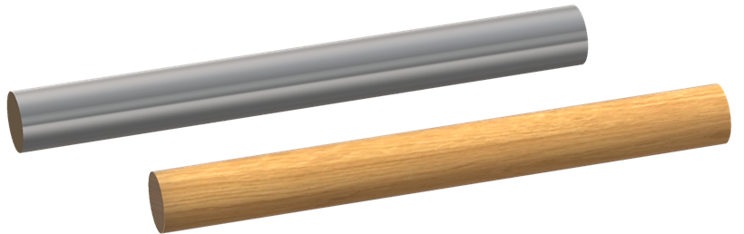

Read these statements about why metal feels cold and wood feels warm.
What do you think about each one?
For each statement, tick (✓) one column to show what you think.
Statements |  | I am sure this is right | I think this is right | I think this is wrong | I am sure this is wrong
A | Energy from the thermal store of your hand moves easily through the metal.
B | Energy from the thermal store of the wood moves into your hand.
C | Energy from the thermal store of your hand does not move easily through wood.
D | The wood feels warm because your hand is warm.

Physics > Big idea PMA: Matter > Topic PMA1: Heating and cooling > Key concept PMA1.3: Thermal conduction
Diagnostic question
Warm feeling

Overview
Learning focus: | Heating makes the particles in a material move more quickly. Heating raises the temperature quickly throughout a good thermal conductor, and very slowly through a good thermal insulator.
Observable learning outcome: | Explain why it is common for thermal insulators to feel warm and thermal conductors cold
Question type: | Confidence grid
Key words: | Thermal store, energy

B | BRIDGING  This diagnostic question probes understanding of ideas that are usually taught at age 14-16, to build a bridge to later stages of learning.

What does the research say?
Although it is a misunderstanding, it can make sense to think that because a plastic chair feels warmer than a metal one it contains more energy in its thermal store. This is a view that Chu et al. (2012) found was held by over 35% of 14- to 16-year-olds (n=344). They also found a similar proportion of 14- to 15-year-olds (n-=178) thought that objects taken out of a fridge felt colder because they contained more ‘cold’. Students aged 12-to 15-years-old do not tend to examine temperature differences and explain phenomena in terms of the direction of energy flowing between thermal stores. Instead they often link properties of an object with what will happen: if it feels cold it will cool, and if it feels warm it will warm. (Erickson and Tiberghien, 1985)
This question uses the energy stores and pathways approach that is described in ‘BEST Approaches: Teaching energy’ (Fairhurst, 2018). ‘Energy stores’ are introduced in the BEST topic PFM1: Forces.
Ways to use this question
Students should complete the confidence grid individually. This could be a pencil and paper exercise, or you could use an electronic ‘voting system’ or mini white boards and the PowerPoint presentation.
If there is a range of answers, you may choose to respond through structured class discussion. Ask one student to explain why they gave the answer they did; ask another student to explain why they agree with them; ask another to explain why they disagree, and so on. This sort of discussion gives students the opportunity to explore their thinking and for you to really understand their learning needs.
Differentiation
You may choose to read the questions to the class, so that everyone can focus on the science. In some situations it may be more appropriate for a teaching assistant to read for one or two students.
Expected answers
A, C and D are correct.
B is wrong.
How to respond - what next?
To answer this question students need to take the scientific approach and consider first where temperature is higher, which is the hand. They then need to think about how easily the energy in the thermal store of the hand can flow through each of the materials.
Answer A is likely to be obvious to most, and similarly answer C because wood is an insulator.
Answer D is correct because the warm hand quickly heats the particles on the surface of the wood. The energy from these particles is not easily conducted through the wood, so they remain at a higher temperature and feel warm to the touch. In a metal energy is quickly transferred away from the surface which reduces the vibrations of its particles, so the surface feels cooler.
A few students may give answer B, which shows they are not approaching the question from the scientific point of view. Instead they are mistakenly linking the properties of an object with what will happen: it feels warm so it will warm.
If students have misunderstandings about why it is common for thermal insulators to feel warm and thermal conductors cold, it can help to take students through the scientific approach to the situation and to then give them opportunities to apply the approach to new examples:
Why does a metal key feel warm when it is taken out of someone’s pocket?
Why does a wooden fence feel cold to touch on a frosty morning?
The following BEST ‘response activities’ could be used in follow-up to this diagnostic question:
- Response activity: Cool rod
Acknowledgments
Developed by Peter Fairhurst (UYSEG).
Images: Peter Fairhurst (UYSEG).
References

